**Install Kafka**

1. Identify java version on your machine

java -version

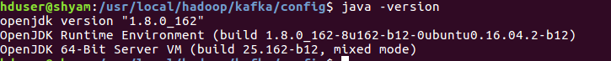

1. Install scala version compatible with java

<https://docs.scala-lang.org/overviews/jdk-compatibility/overview.html>

**UBUNTU:**

sudo apt-get remove scala-library scala

sudo wget http://scala-lang.org/files/archive/scala-2.11.0.deb

sudo dpkg -i scala-2.11.0.deb

rm -f scala-2.11.0.deb

1. Download kafka compatible with scala version from https://kafka.apache.org/downloads

tar -zxvf

1. Add following content to .bashrc file

#KAFKA VARIABLES START

*export KAFKA_HOME=$HADOOP_INSTALL/kafka*

*export PATH=$PATH:$KAFKA_HOME/bin*

#KAFKA VARIABLES END

1. Apply .bashrc file

source ~/.bashrc